PTS Database Configuration Install Notes

Matt Heller, GNLCC/USFWS 1/19/16

Contents

Python Environment Setup 1

If requests does not exist 2

If pysb does not exist 3

Download custom python scripts 4

Microsoft Access File Setup 5

Download custom MS Access File if needed 5

Download custom GIS files 5

Edit the setting tab 5

# Python Environment Setup

1. Verify ArcGIS Desktop 10.2 or higher is installed on workstation

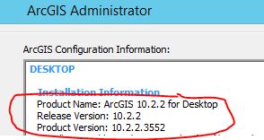

If ArcGIS Desktop 10.2 is not installed, for FWS staff open FWS Apps to Go and install ArcGIS 10.3.1

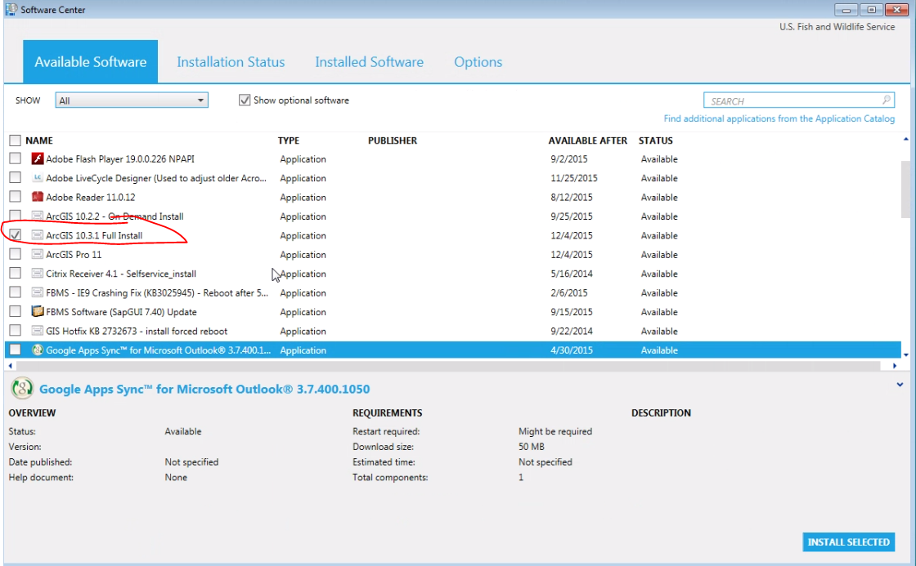

1. Verify the python libraries arcpy, requests, and pysb are configured
   1. From the dos command prompt

🡪 Enter the path to your python.exe *(C:\Python27\ArcGISx6410.3\python.exe, C:\Python27\ArcGISx6410.2\python.exe, C:\Python273\ArcGISx6410.2\python.exe)*

🡪 Enter help(“modules”)

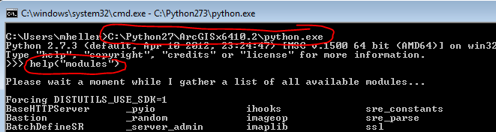

* 1. Click ctl-Z to exit

1. If **arcpy** library does not exist, try checking a different python.exe path *(C:\Python27\ArcGISx6410.2\python.exe, C:\Python273\ArcGISx6410.2\python.exe)*

### If requests does not exist

1. Download python’s pip… <https://bootstrap.pypa.io/>

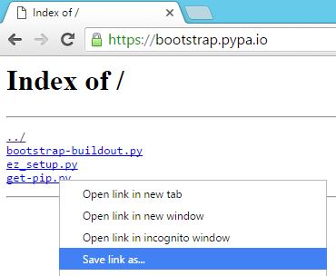

1. install pip

*(i.e. C:\Users\MatthewHeller>C:\Python27\ArcGISx6410.2\python.exe Q:\Shared\Software_Install_Files\OpenSource_Free\Python_Pip\get-pip.py)*

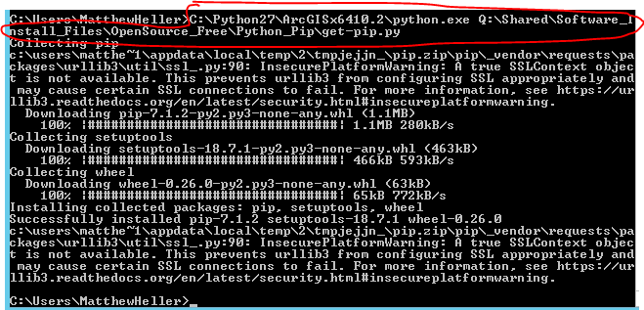

1. Download requests install from… <https://pypi.python.org/pypi/requests>

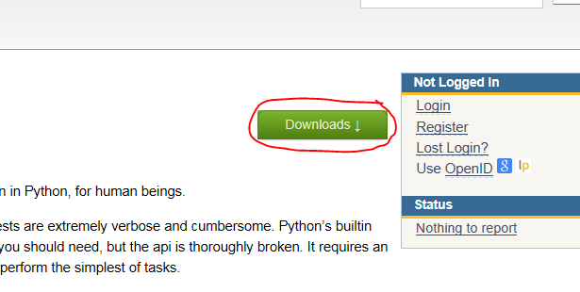

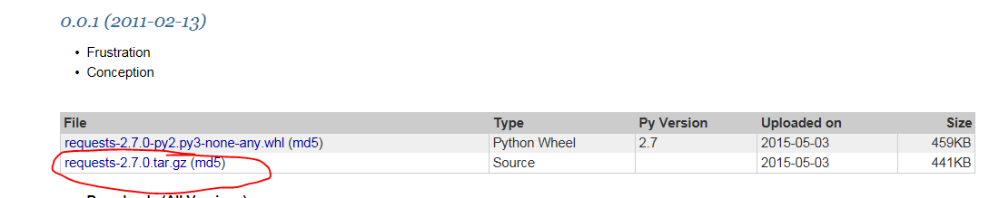

1. Extract from the .gz file 🡪 Extract from the .tar file

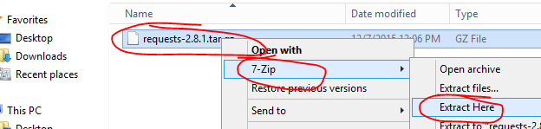

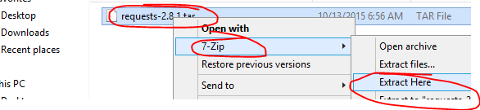

1. Install request module

*(i.e. C:\Python27\ArcGISx6410.2\scripts\pip.exe install Q:\Shared\Software_Install_Files\OpenSource_Free\Python2.7Requests_v2.8.1\dist\requests-2.8.1)*

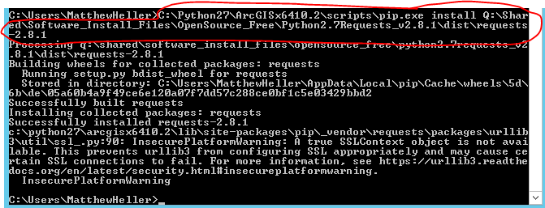

### If pysb does not exist

1. Download pysb <https://my.usgs.gov/stash/projects/SBE/repos/pysb/browse>

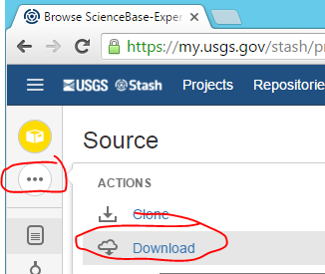

1. Extract from the .zip file

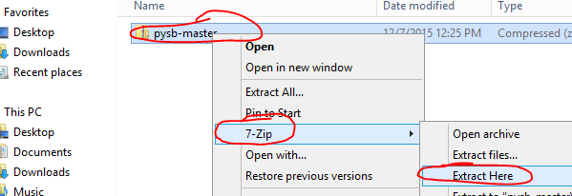

1. Install request module

*(i.e. C:\Users\MatthewHeller>C:\Python27\ArcGISx6410.2\scripts\pip.exe install C:\PCProg\pysb)*

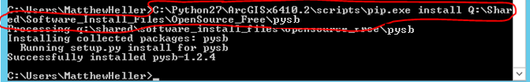

### Download custom python scripts

Download the scripts from these 2 Sciencebase items to a non-tempory folder. Unzip the export2AGS item.

<https://www.sciencebase.gov/catalog/item/569e784ce4b0961cf27fafc9>

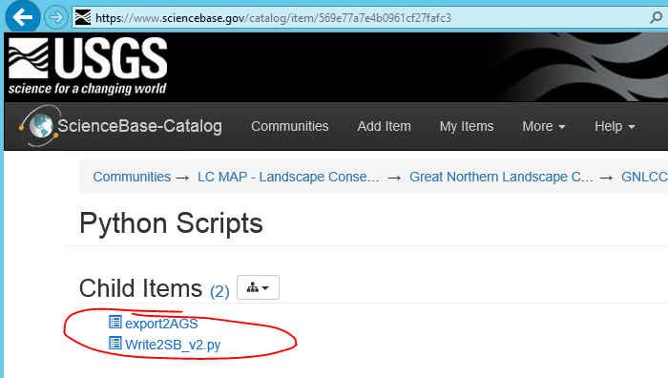

# Microsoft Access File Setup

### Download custom MS Access File if needed

NPLCC: <https://www.sciencebase.gov/catalog/folder/53d2a728e4b07d2566eeed02>

SRLCC: <https://www.sciencebase.gov/catalog/folder/5679cd92e4b0da412f4fc2ea>

### Download custom GIS files

1. Download the File Geodatabase .zip file 🡪 unzip 🡪 copy to non-temp folder

NPLCC: <https://www.sciencebase.gov/catalog/item/569e75dce4b0961cf27fa55e>

SRLCC: <https://www.sciencebase.gov/catalog/item/569e76bbe4b0961cf27fafbb>

1. MXD

NPLCC: <https://www.sciencebase.gov/catalog/item/569e7616e4b0961cf27fafb6>

SRLCC: <https://www.sciencebase.gov/catalog/item/569e76f3e4b0961cf27fafbd>

1. Open MXD and repair data sources 🡪 save MXD 🡪 close

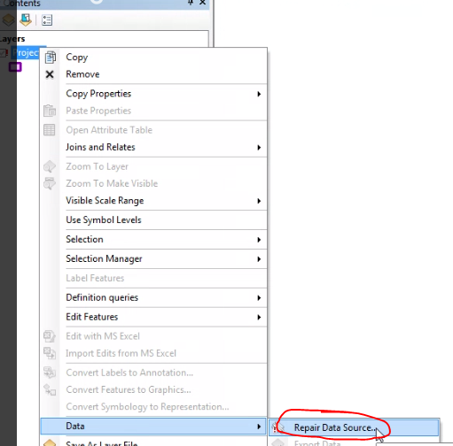 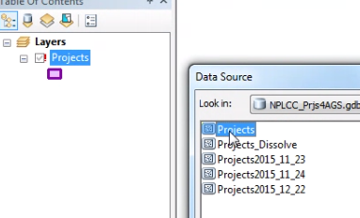

### Edit the setting tab in the MS Access File

If error pops up

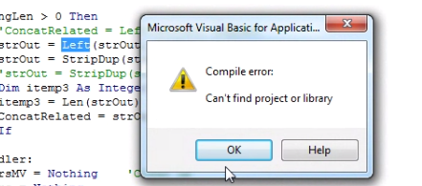

 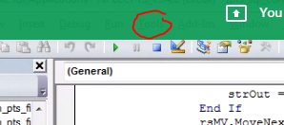

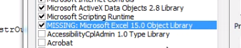

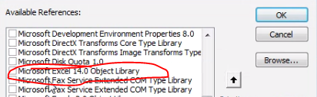 

Open the MS Access File and enter accordingly

NPLCC AGS ID: 5653657ae4b071e7ea53ce52

SRLCC AGS ID: 5679cdaae4b0da412f4fc2ec

SRLCC Parent ID: 5679cd92e4b0da412f4fc2ea

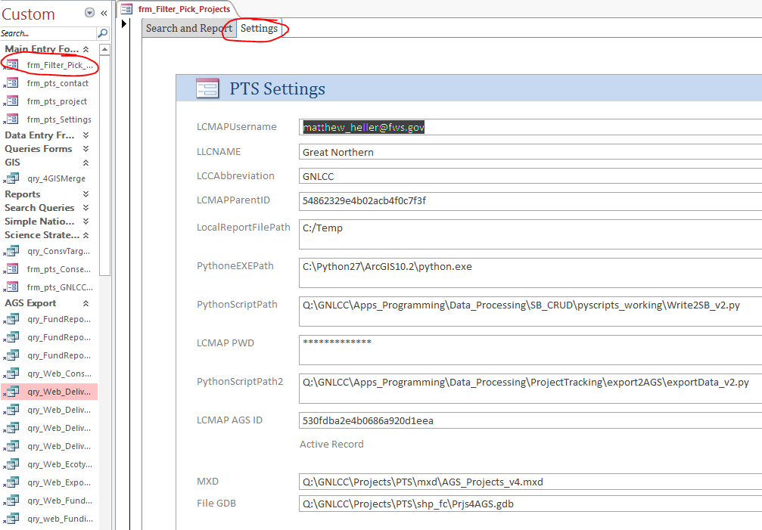

### Test the Configuration

1. Log into SB
2. Download the sd file from Sciencebase as a backup

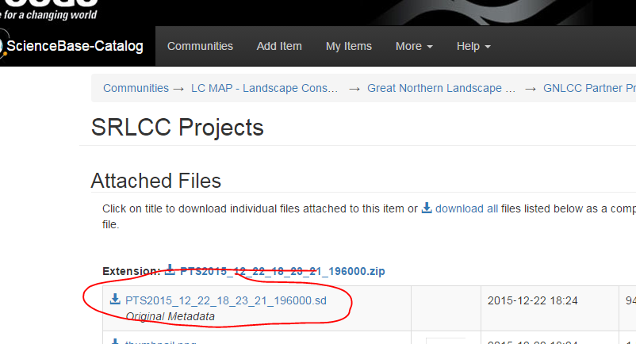

SRLCC: https://www.sciencebase.gov/catalog/item/5679cdaae4b0da412f4fc2ec

NPLCC: https://www.sciencebase.gov/catalog/item/5653657ae4b071e7ea53ce52

1. Remove the AGS map service

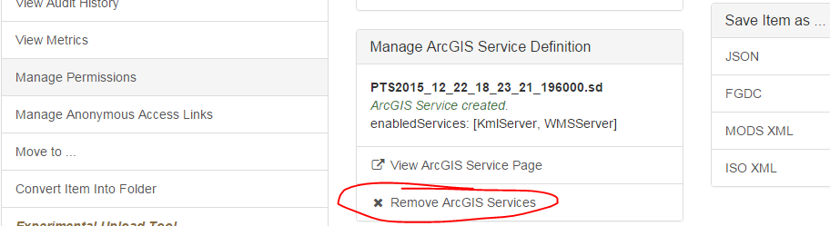

1. Remove the SD extension 🡪 save

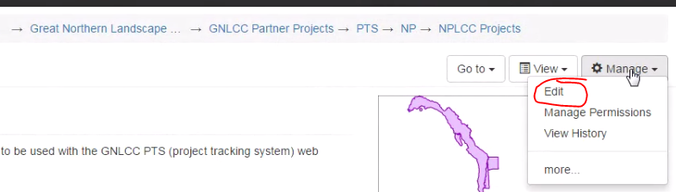

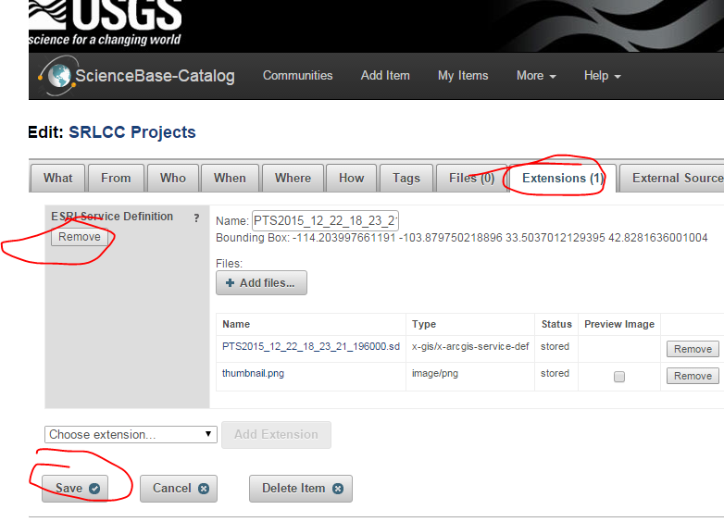

1. With internet explorer log into SB
2. Click “Export to AGS” Button

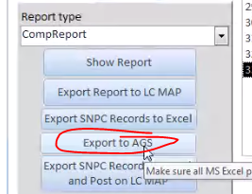

# Routine Steps

# Digital Resources

NPLCC Draft PTS Web App: <http://mmheller.github.io/GNLCC_PTS4_NPLCC/index.html>

SRLCC Draft PTS Web App: <http://mmheller.github.io/GNLCC_PTS4_SRLCC/index.html>